# Self-driving cars survey

Please answer the following questions about your attitude regarding self-driving cars.

|  |  |  |  |  |  |
| --- | --- | --- | --- | --- | --- |
| Statement | Strongly Agree | Agree | Neutral | Disagree | Strongly Disagree |
| 1. Self-driving vehicles will provide an overall benefit to society |  |  |  |  |  |
| 1. I would purchase a self-driving vehicle if it was commercially available and comparable in price to a conventional vehicle. |  |  |  |  |  |
| 1. If an accident is unavoidable, the priority of a self-driving vehicle should be to protect its passengers |  |  |  |  |  |
| 1. If an accident is unavoidable, the priority of a self-driving vehicle should be to save as many lives as possible rather, even if this means sacrificing one or more passengers. |  |  |  |  |  |
| 1. I would purchase a self-driving car that was programmed to sacrifice its passengers for the greater good if it prevented less casualties. |  |  |  |  |  |
| 1. If an accident is unavoidable, a sacrifice of a pet or an animal should always be chosen over the sacrifice of a person |  |  |  |  |  |

For the next two questions, please circle your response.

1. Who should be responsible for the cost of damages in the case where a self-driving car gets into an accident?
   1. The Car Manufacturer
   2. The auto-pilot software company
   3. Car insurance company
   4. The government
   5. None of the above
2. If you had an autonomous vehicle how would you spend your time instead of driving?
   1. Enjoying the scenery
   2. Consuming entertainment (TV, Books, Games, Phone)
   3. Being productive(schoolwork, work)
   4. Sleeping
   5. Being social (talking to passengers, social media
   6. Other (please describe)

The following scenarios correspond to situations where an accident is unavoidable, and a self-driving car has to make a decision about whether passengers or bystanders will be sacrificed.

In these scenarios, a **skull** indicates a person that will be sacrificed.

Please select which choice (A or B) a Self-Driving car should make when faced with the five dilemmas below:

**Dilemma #1**

A B

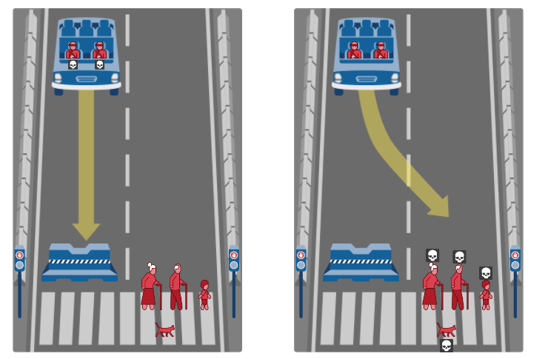

Dilema 1(old man,old woman,child,cat)

A - 6

B - 8

57% agreed to kill pedestrians rather than kill them selves despite there being 2 elders and 1 child and a cat.

It must be noted though that when participants that said at ques 3 that

**Dilemma #2**

A B

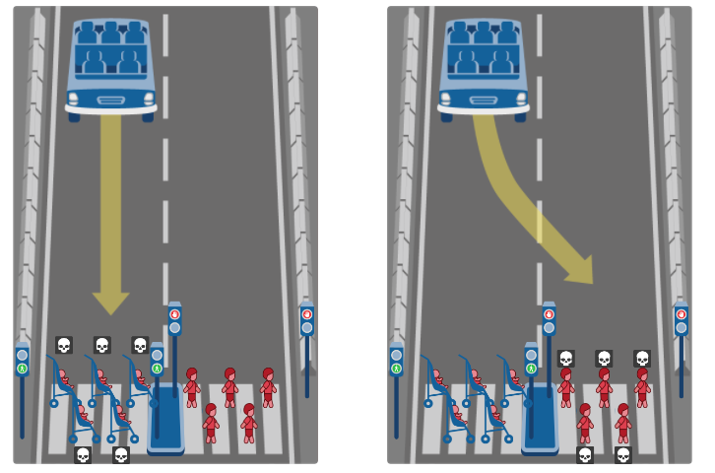

Dilema 2(babies vs toddlers)

A - 5

B - 9

64% chose to kill toddlers rather than kill babies. Perhaps because toddlers lived a longer life , so mayb life were seen as being worth less.

**Dilemma #3**

A B

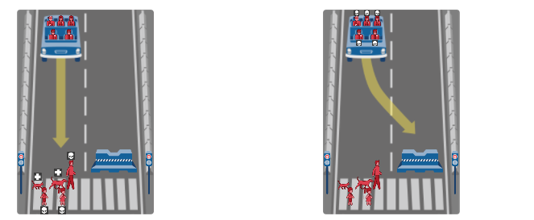

Dilema 3(man and son and daugther die but cat and dog live)

A - 11

B - 3

78% chose to kill man,daugther and chill rather than self-sacrifice themselves. Dog and cat were spared but not sure if this affected the choice????

Could it also be that we are so adamant to survive that we refuse o self-sacrifice hence why B was only 3??

It must be noted that the 3 that chose B for the dilemma , were not consistent as their answers for question 4 ranged from agree, strongly agree and neutral.The only strongly agree for the entire study was one of the participants which chose B for D3.

The 2 only 2 participants that were disagreed with the sacrifice for pet life over human life ques 6 both chose A in D3 to kill which would save the pets…..

**Dilemma #4**

A B

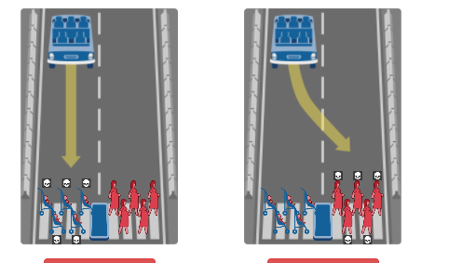

A - 13

B - 1

92% chose to kill babies rather than kill pregnant women. Based on the correlation with Dilemma 2 it would appear that life which is younger has first preference. This includes newborn babies as well (highest priority it seems). Then would old life be the lowest??????

**Dilemma #5**

A B

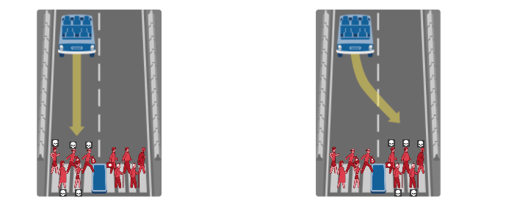 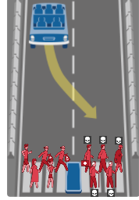

Dilema 5( preggy,woman,robber vs doc,old man,old woman, hobbo)

A - 12

B - 2

85% chose to kill preggy,robbers and women to save doctor,man,hobbo and 2 old men. This is interesting as the life of the preggy should be at top priority. Especially since there are TWO older men on the B side which would mean that based on previous correlation that old life is less of a priortiy.However it is important to note that the doctor was spared is this because he can save more lives so his life is worth more than just one. Would occupational status thus determine priority.

Question 5 proved that I could divide participants into those in agreement with self-sacrifice and those against. The same participants that chose dilemma 3 A and B. A had also the only person willing to buy an AV programmed to self sacrifice with the other 2 being Neutral. In the other still group set B only 3 neutrals were there with the other choices being disagree and strongly disagree.

The only 2 participants that chose B , both had the exact same answers for each dilemma but answers for previous ques all differed

Occupational status seemed to have more of an impact than gender as only 2 rather to kill B than A which had more women

**7.Responsible**

Manufacturer : 3

Software : 7

Insurance : 5

Gov : 0

Majority of participants believe that the software company should be blamed. There is also close agreement with some fault to be placed on Insurance companies too.

8.Time

Scenery: 2

Entertainment : 5

Productive :7

Sleep: 7

Social: 0

Other: 1

Majority of participants would be more productive if an AV was avalilable. They would also spend equal time being productive. These are followed by entertainment. With observing the scenery being poorly used.

Dilema 1(old man,old woman,child,cat)

A - 6

B - 8

57% agreed to kill pedestrians rather than kill them selves despite there being 2 elders and 1 child and a cat.

Dilema 2(babies vs toddlers)

A - 5

B - 9

64% chose to kill toddlers rather than kill babies. Perhaps because toddlers lived a longer life , so mayb life were seen as being worth less.

Dilema 3(man and son and daugther die but cat and dog live)

A - 11

B - 3

78% chose to kill man,daugther and chill rather than self-sacrifice themselves. Dog and cat were spared but not sure if this affected the choice????

Could it also be that we are so adamant to survive that we refuse o self-sacrifice hence why B was only 3??

Dilema 4(babies vs preggy)

A - 13

B - 1

92% chose to kill babies rather than kill pregnant women. Based on the correlation with Dilemma 2 it would appear that life which is younger has first preference. This includes newborn babies as well (highest priority it seems). Then would old life be the lowest??????

Dilema 5( preggy,woman,robber vs doc,old man,old woman, hobbo)

A - 12

B - 2

85% chose to kill preggy,robbers and women to save doctor,man,hobbo and 2 old men. This is interesting as the life of the preggy should be at top priority. Especially since there are TWO older men on the B side which would mean that based on previous correlation that old life is less of a priortiy.However it is important to note that the doctor was spared is this because he can save more lives so his life is worth more than just one. Would occupational status thus determine priority.